Diagnostic Analysis Report

1) Objective
The objective of this diagnostic analysis is to identify low sales patterns across regions and products, and cross-check operational performance to determine potential root causes (e.g., higher fulfillment days). The analysis uses both Sales and Operations data.

2) Dataset Used
This report is based on integrated Sales and Operations data.
Sales Data (Key fields): Region, Revenue, Month, Product
Operations Data (Key fields): Fulfillment Days, Region, Product

3) Sales Findings (Where sales are low?)
Region-wise Revenue:
EAST has the lowest revenue compared to other regions

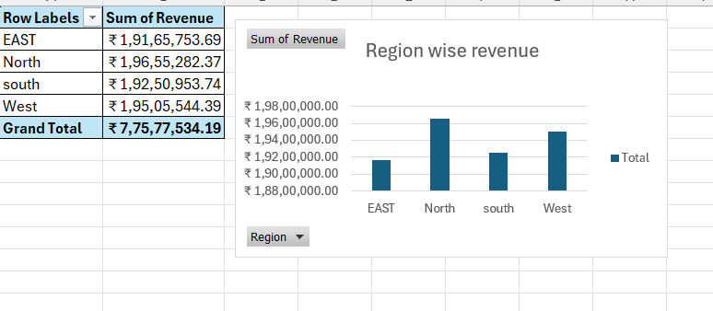

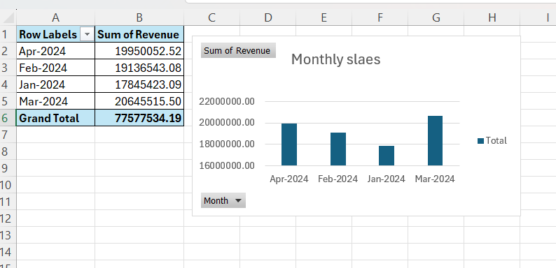
Monthly Sales Trend:
Revenue varies by month, with January being the lowest month and March being the highest

Region-wise Monthly Sales:
Across months, EAST remains consistently lower than other regions
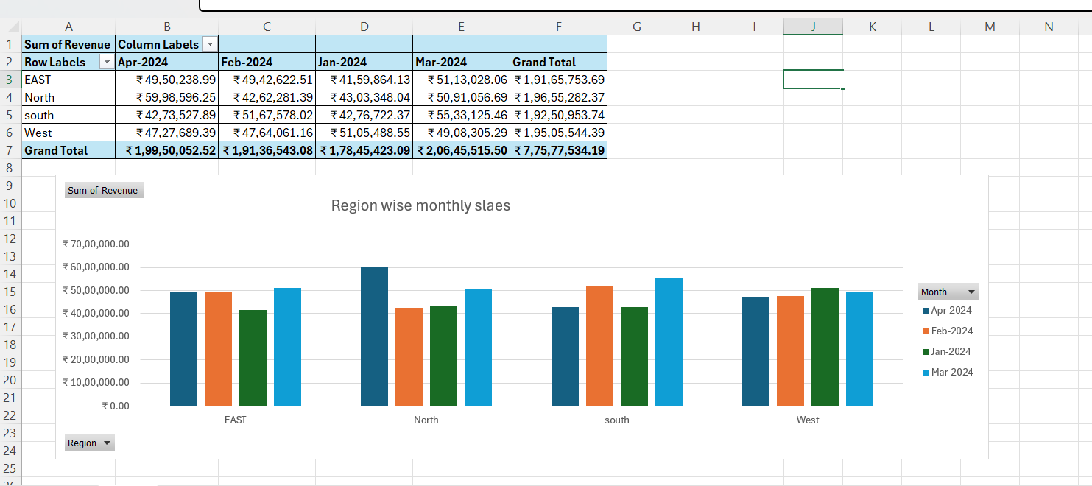

Product + Region Revenue:
Phone dominates revenue across all regions, while Laptop revenue remains low across all regions
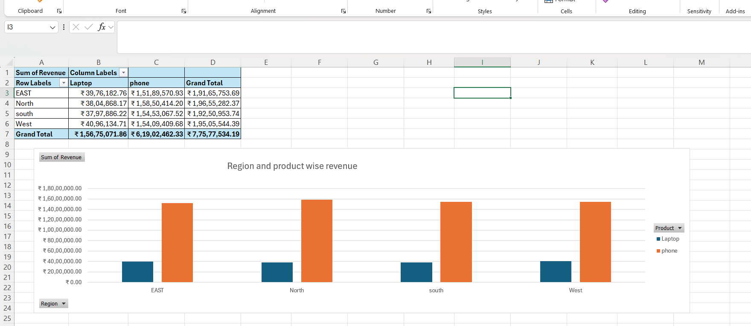

Operations Cross-check (Is low sales linked to fulfillment delays?)
Average Fulfillment Days by Region & Product:
EAST has the highest average fulfillment days overall. Laptop orders in EAST show the highest fulfillment time among region-product combinations
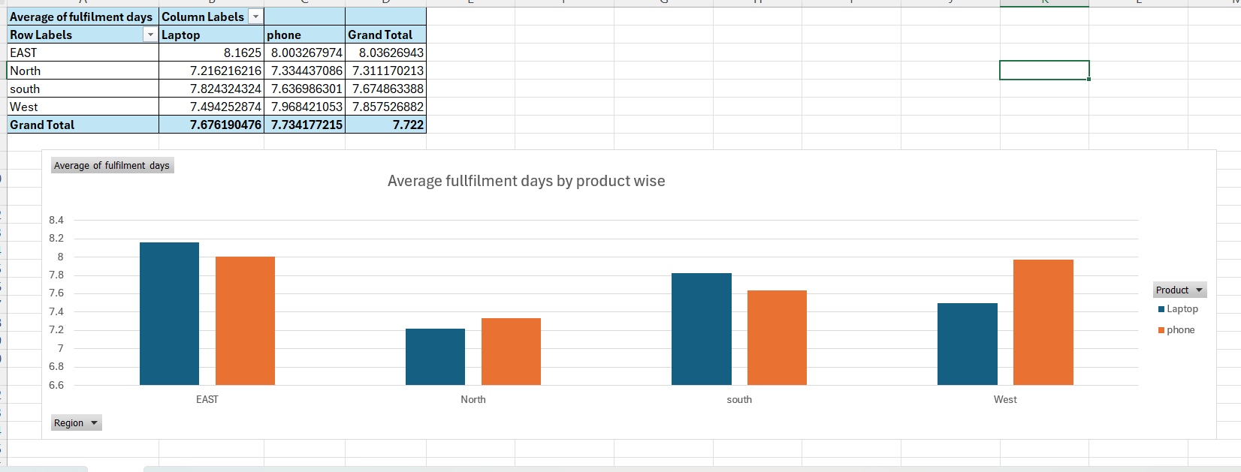

Root Cause Analysis (2–3 Causes)
Root Cause 1:
EAST region has the slowest fulfillment time, which may reduce customer satisfaction and repeat purchases.
Root Cause 2:
Laptop category has weaker sales performance across all regions, indicating possible demand, pricing, or availability issues.
Root Cause 3
(Supporting): EAST + Laptop combination shows the highest fulfillment time, making it a high-risk segment for low sales.

Conclusion
The analysis indicates that EAST is the lowest-performing region in revenue and also shows the highest fulfillment days. Additionally, Laptop is the lowest-performing product category across regions. These factors together suggest that operational delays and product-level performance issues are likely contributing to low sales patterns.

Practical Recommendations (Action Plan)
1. Reduce fulfillment time in EAST by monitoring delayed shipments and improving warehouse/process efficiency.
2. Improve Laptop sales through targeted promotions, pricing review, and ensuring availability.
3. Track weekly KPIs: Region revenue, fulfillment days, delayed orders %, and Laptop sales trend.

